New Delhi, India

October 23, 2024



USER INTERFACE GUIDE

*Vegetable Irrigation for Climate Resilience Toolkit (VICT) Platform*

Table of Contents

1.0 INTRODUCTION 3

2.0 USER INTERFACE 4

2.1 HOME 4

2.2 RESOURCE CENTER 8

**2.2.1 ABOUT VICT** 9

**2.2.2 PUBLICATION** 10

**2.2.3 GUIDELINE AND TOOLS** 11

**2.2.4 VIDEOS** 12

2.3 EXPLORE DATA 13

2.4 DECISION PROCESS 17

2.5 CONTACT 18

# 1.0 INTRODUCTION

The **Vegetable Irrigation for Climate Resilience (VICT)** platform is developed as a web-based platform that uses a data-driven, evidence-based approach to support humanitarian agencies in designing and implementing irrigation investments for vegetable production. The platform comprises of various modules including the user interface and data management. Users with appropriate roles has the access to their restricted modules.

The User Interface application contains the following modules -

1. Home
2. Resource Center
3. Explore Data
4. Decision Process
5. Contact
6. Search

Each of these modules are explained in detail.

# 2.0 USER INTERFACE

The **Vegetable Irrigation for Climate Resilience (VICT)** platform is a web-based tool which can be accessed through a web browser (recommended browser - Google Chrome latest version). Enter URL <https://vict.itechmission.org/toolkit/> in the web browser. The first page you will get to view is the home page. The home page has the options available to navigate through all the modules of the user interface application – **Home**, **Resource Center**, **Explore Data, Decision Process, Contact** and **Search**. Let us learn about how to use these modules.

## 2.1 HOME

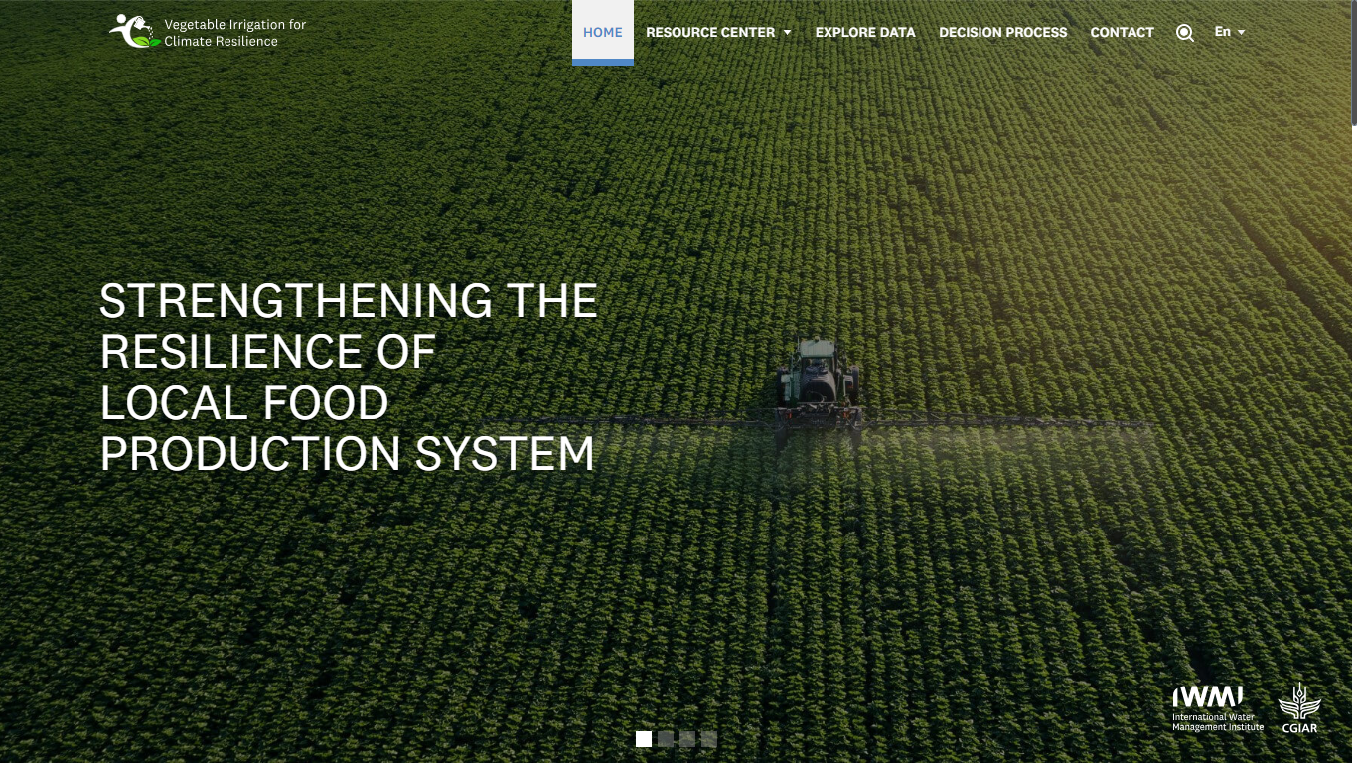This is the landing page of the platform which consist of five sections. The first section presents the branding guidelines, platform’s logo, Slider images and header menu to navigate to the other modules of the platform. You have the option to switch between the sliders by clicking on the square icons available at the bottom of the page. The **home page** serves as the central hub for users to engage with the platform. It is designed to provide a seamless user experience and easy navigation using the header menu as well (see below figure).

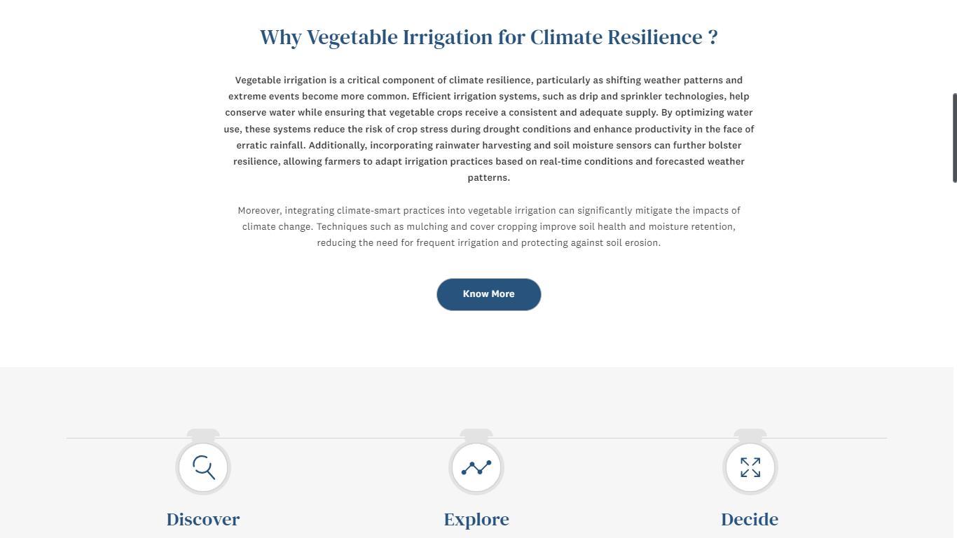The second section of the home page addresses the importance of vegetable irrigation for climate resilience. A "**Know More**" button is available at the bottom that will redirect you to the "**About VICT**" page under the Resource Center module for additional information (see below figure).

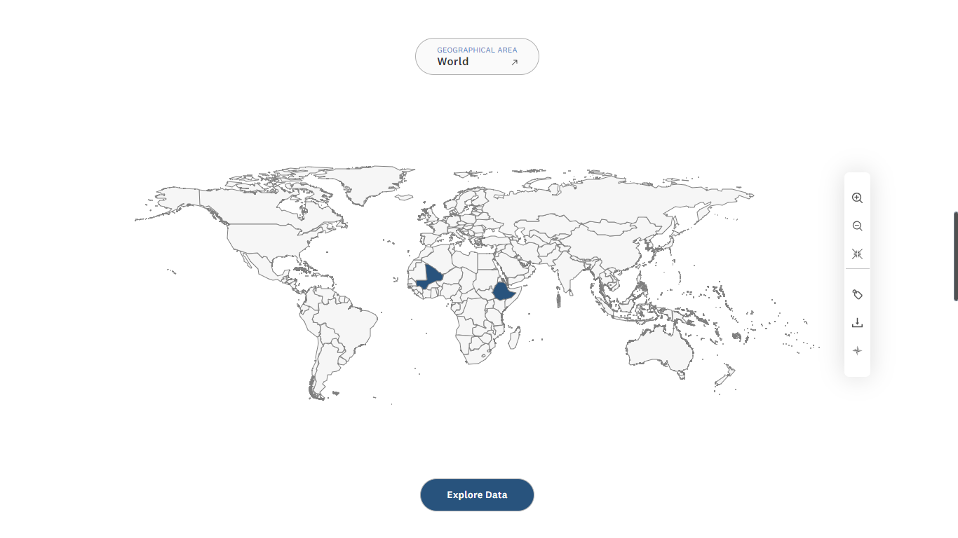The third section appears as you scroll down and displays a world **thematic map**. The map highlights areas in **blue**, indicating regions where data is available. You can interact with the map by clicking on these blue-colored regions, which will navigate you directly to the **Explore Data** module (see below figure).

You can also navigate to the Explore Data module by clicking on the respective button available at the bottom of the map.

There is also a map toolbar available to the right side of the map which has the following options.

* Zoom in
* Zoom out
* Reset
* Label on/off
* Download
* North Symbol

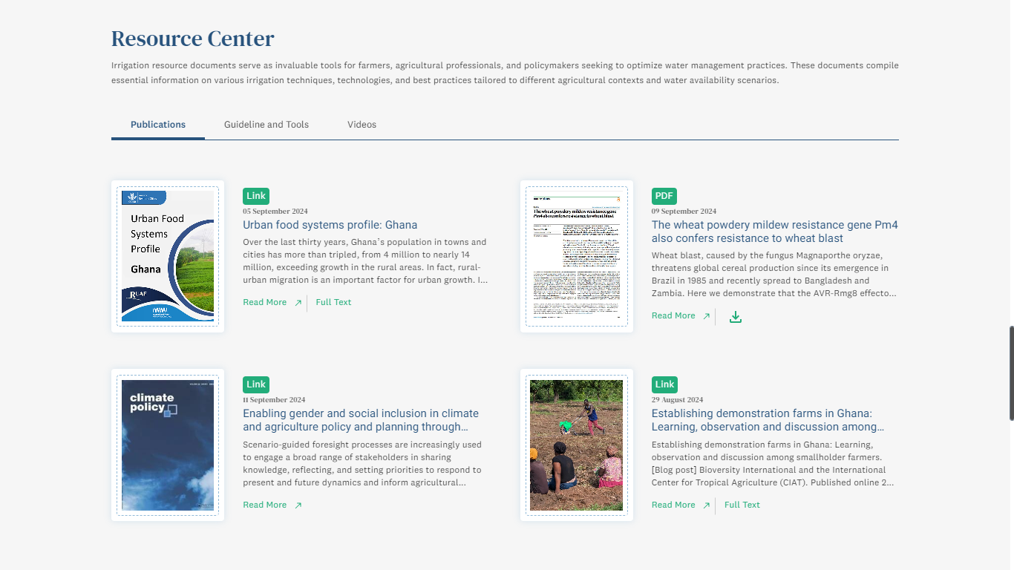The fourth section of the home page provides a brief description of the Resource Center module and showcases three key categories: Publications, Guidelines and Tools, and Videos. Each category displays four featured resources, giving users a quick overview of the available content. There is also an option to **View All** the resources to navigate to the Resource Center module and view the complete resources (see below figure).

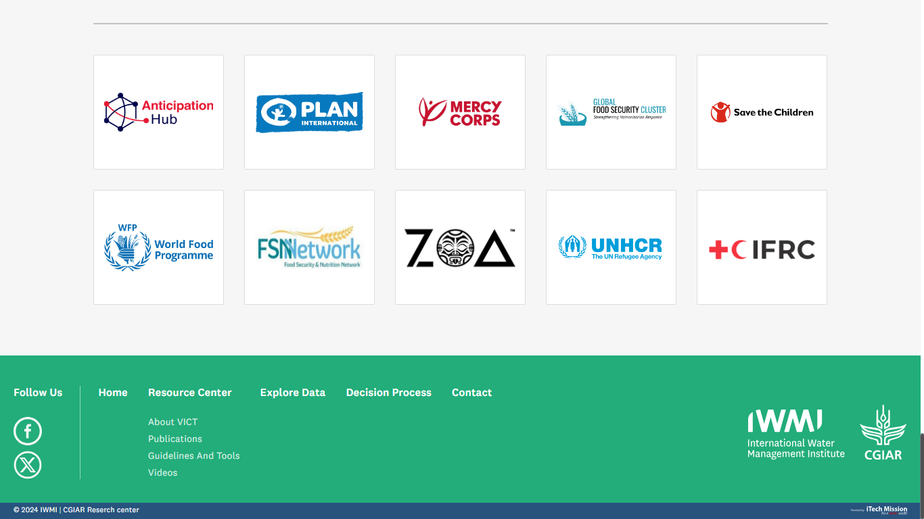The fifth and last section of the home page shows the partners' logos. Below that is the footer, which includes navigation menus that allow users to navigate to the other modules of the platform. It also provides links to the platform’s social media pages (see below figure).

## 2.4 DECISION PROCESS

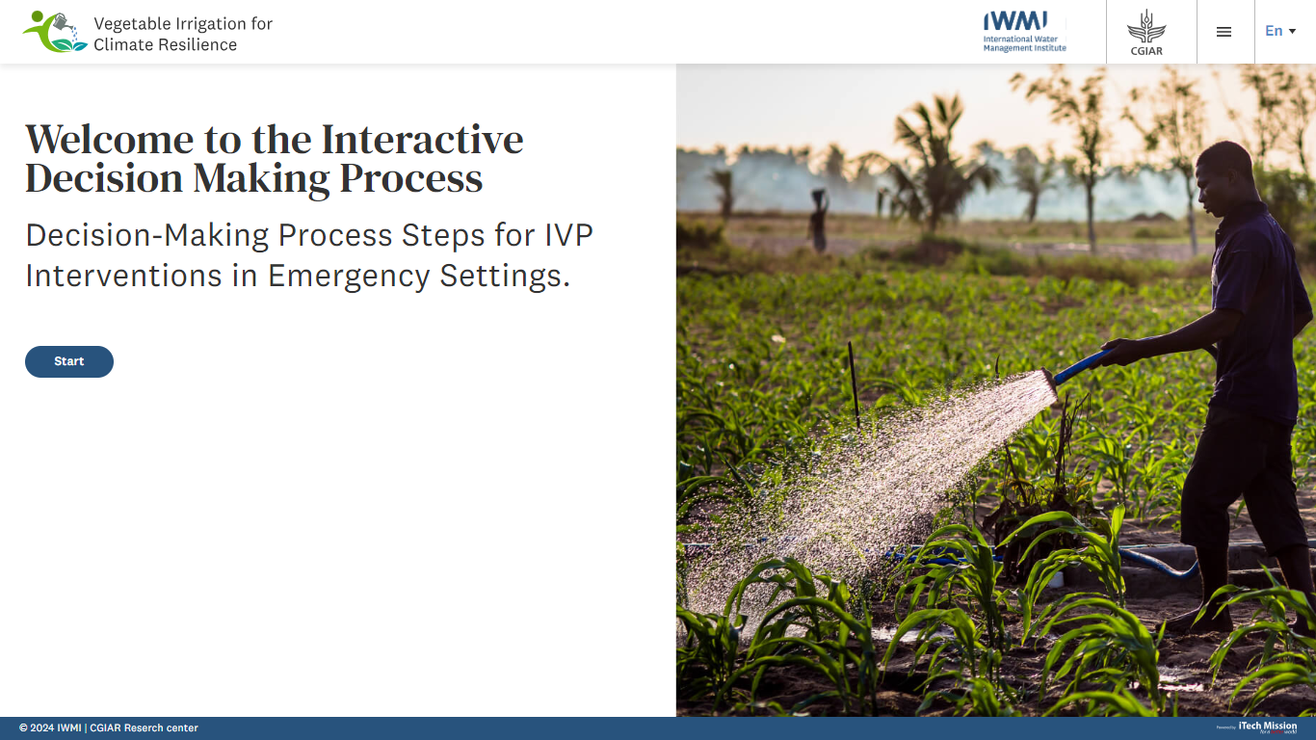Click on the **Decision Process** option from the main menu to navigate to the module. This module provides a systematic framework for implementing **Irrigation and Vegetable Production (IVP)** interventions in emergency settings. This process contains a series of **nine steps**, each designed to guide you through a comprehensive decision-making process. Each step includes a set of targeted questionnaires that gather information, with scoring assigned to each response (see below figure).

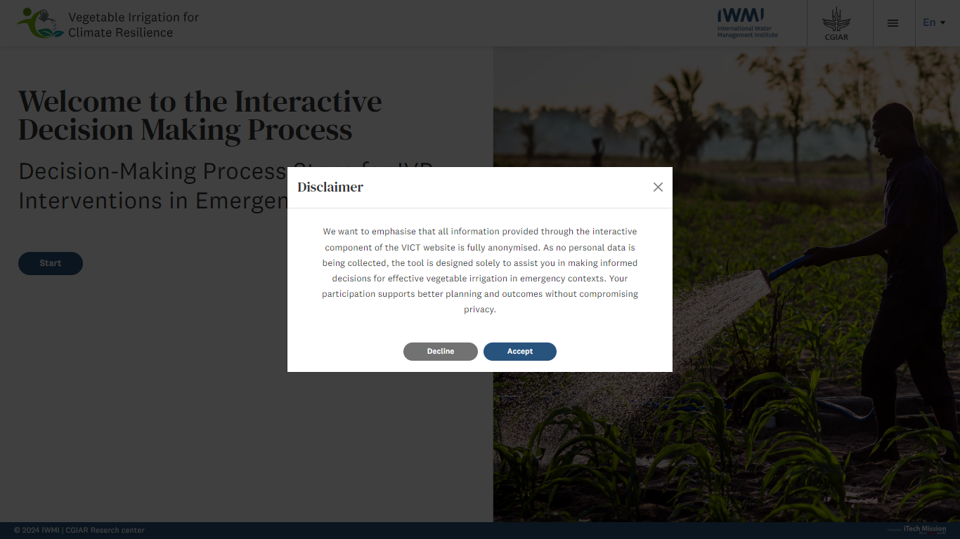Click on the **Start** button to start the process. A pop-up will appear that contains terms and conditions. You will have the option to **Accept** or **Decline** the terms before proceeding further in the module.

## 2.3 EXPLORE DATA

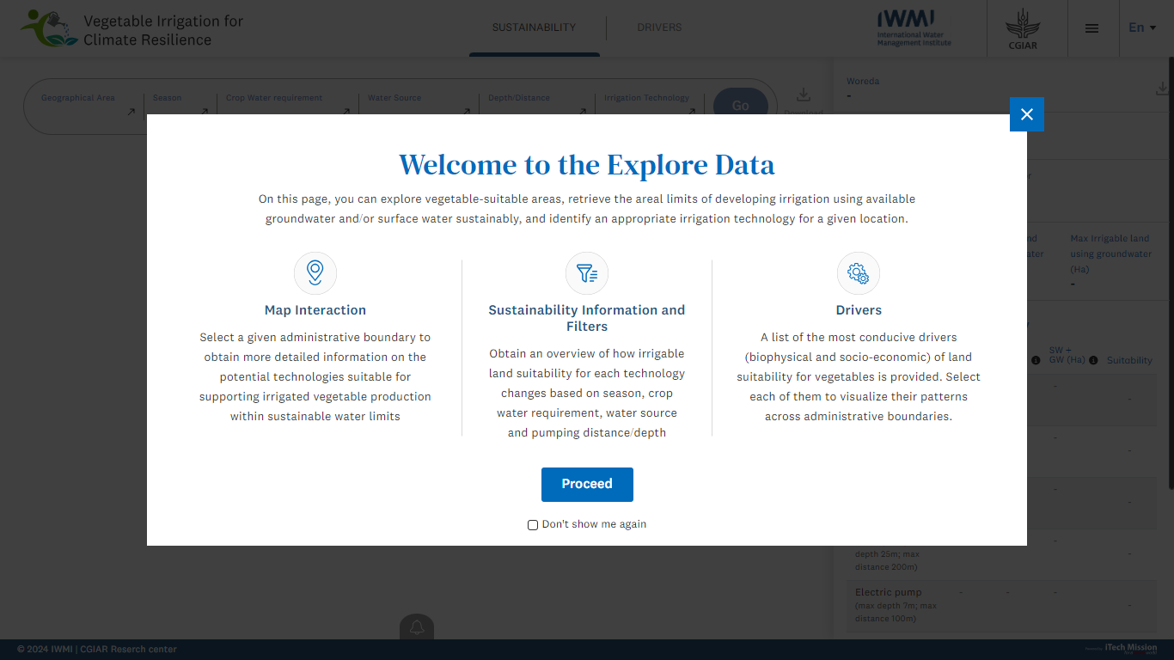Click on the **Explore Data** option from the main menu to navigate to the module. A pop-up window will appear that presents a welcome text and provides a brief description of how to use this module. You also have the option to check the “**Don’t show me again**” box if you prefer not to see this message in the future. After reading the information, click on the **Proceed** button moving ahead (see below figure).

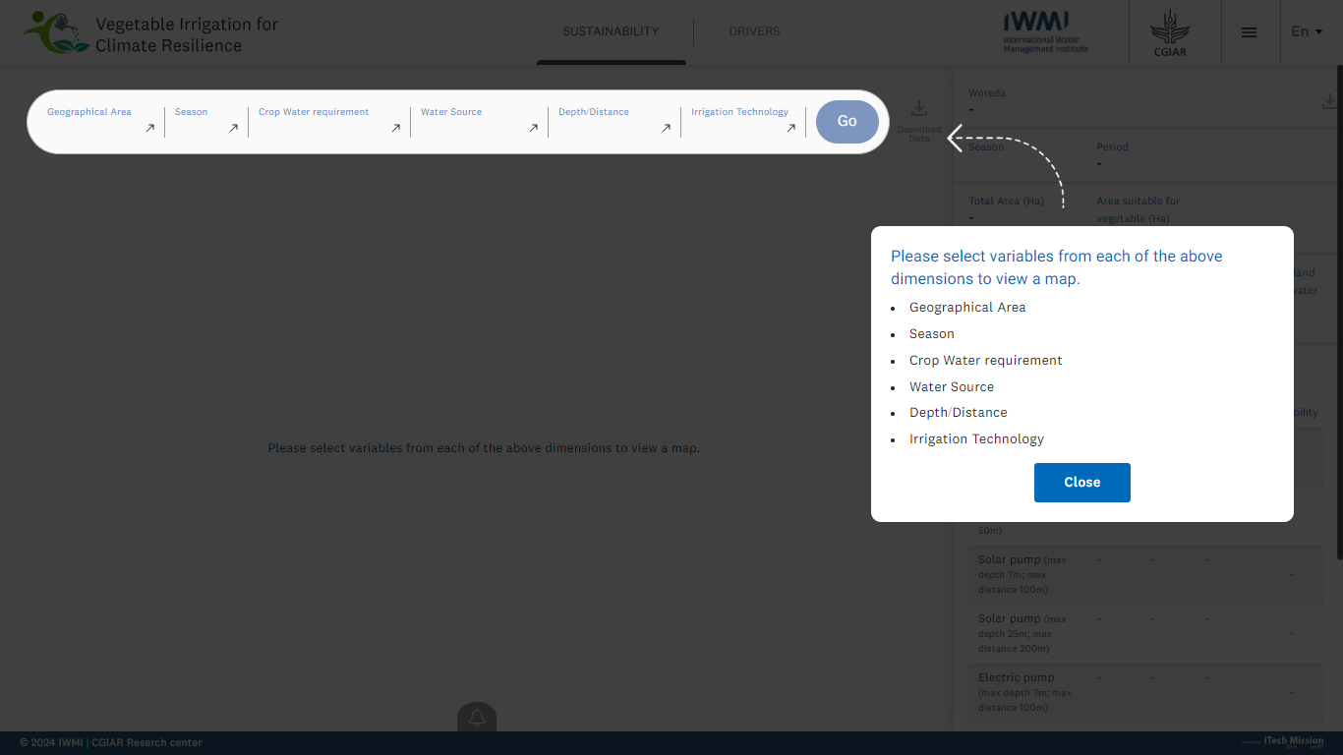After clicking the Proceed button, a step-by-step presentation will guide you through how to use the Explore Data module. It prompts you to select variables from following dimensions - geographical area, season, crop water requirements, water source, depth/distance, and irrigation technology, to generate a map. Click on the **Close** button to exit the guide (see below figure).

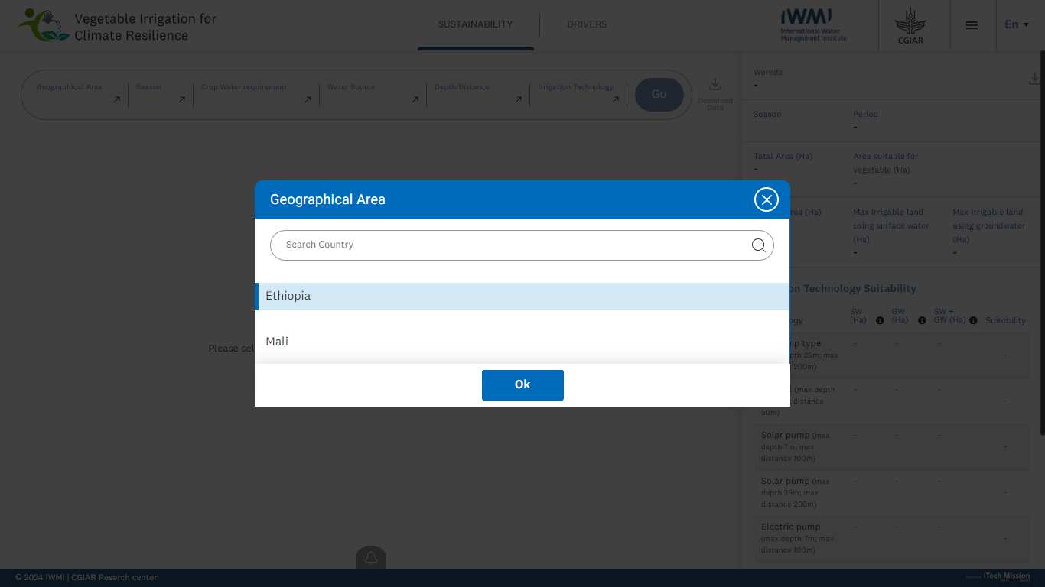Once you click on Close, a pop-up will appear that will allow to you to search and select one of the geographical areas from the list. Select the required area and click the **OK** button to confirm your selection (see below figure).

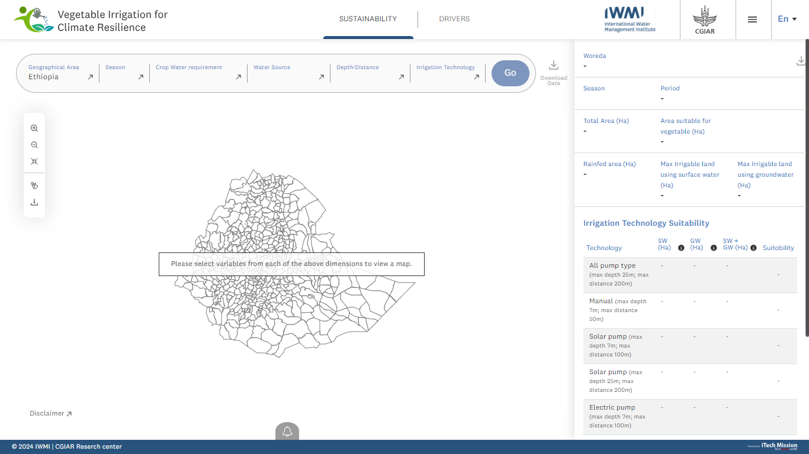The map of the selected area will appear along with a message that instructs you to select the other required variables to view the respective data (see below figure).

By default, you will be redirected to view the **Sustainability** data. You can also select the **Drivers** option from top to view the respective data (see above figure).

Select the required variables and click on the **Go** button to view the data on the color theme map of the selected area (see below figure).

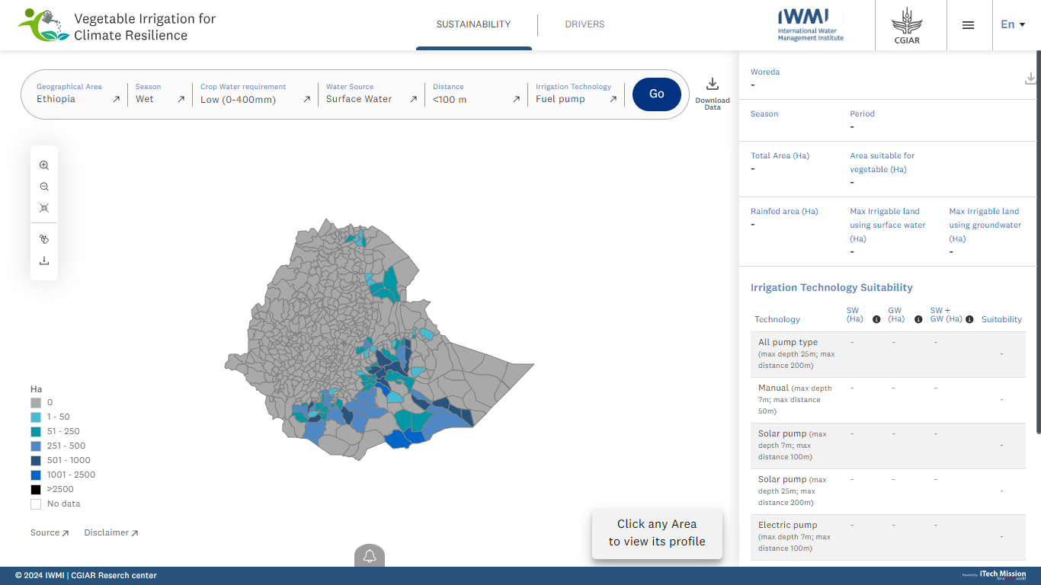A **legend** is available to the left side of the map that will help you understand the data range appearing on the map. There is also a map toolbar available to the left side of the map that allows to perform the following actions –

* Zoom in
* Zoom out
* Reset
* Label on/off
* Download

Click on the **Download** data option available to the top right corner of the page to download the data in CSV format.

The **Source** of the data and **Disclaimer** is available at the bottom of the map. Hover on the arrow button available with both to view the respective information.

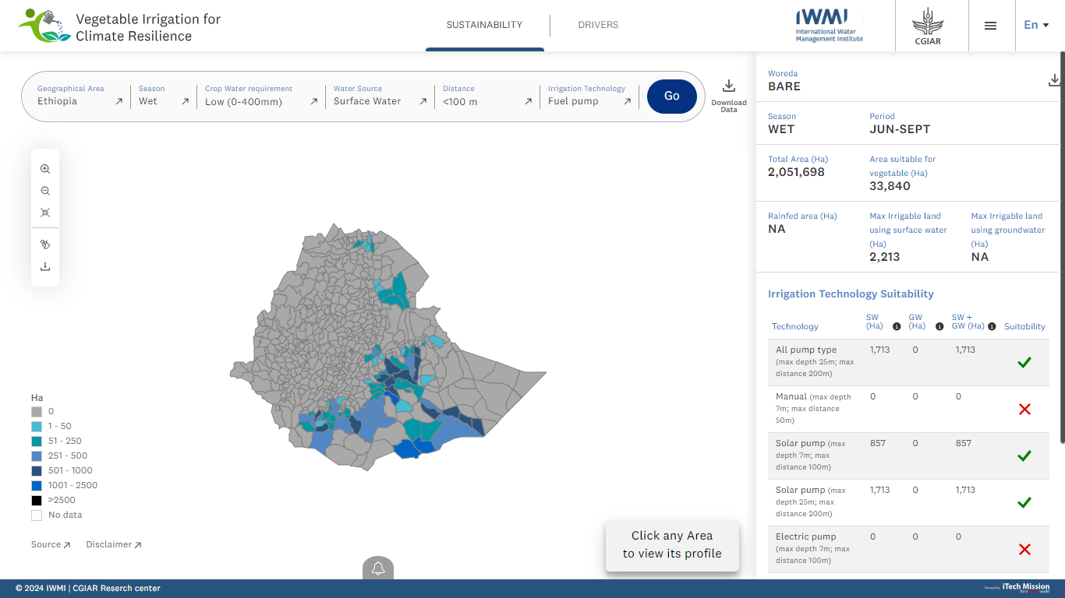You can click on the **Area** from the map to view its profile to the right side (see below figure).

Click on the **burger menu** available at the top right corner of the page to navigate to the other module. There is also an option to change the language of the portal by selecting of the option from the list (English or French).

## 2.2 RESOURCE CENTER

Click on the **Resource Center** option from the main menu to navigate to the module. This module has four sub-modules -

1. About VICT
2. Publications
3. Guideline and Tools
4. 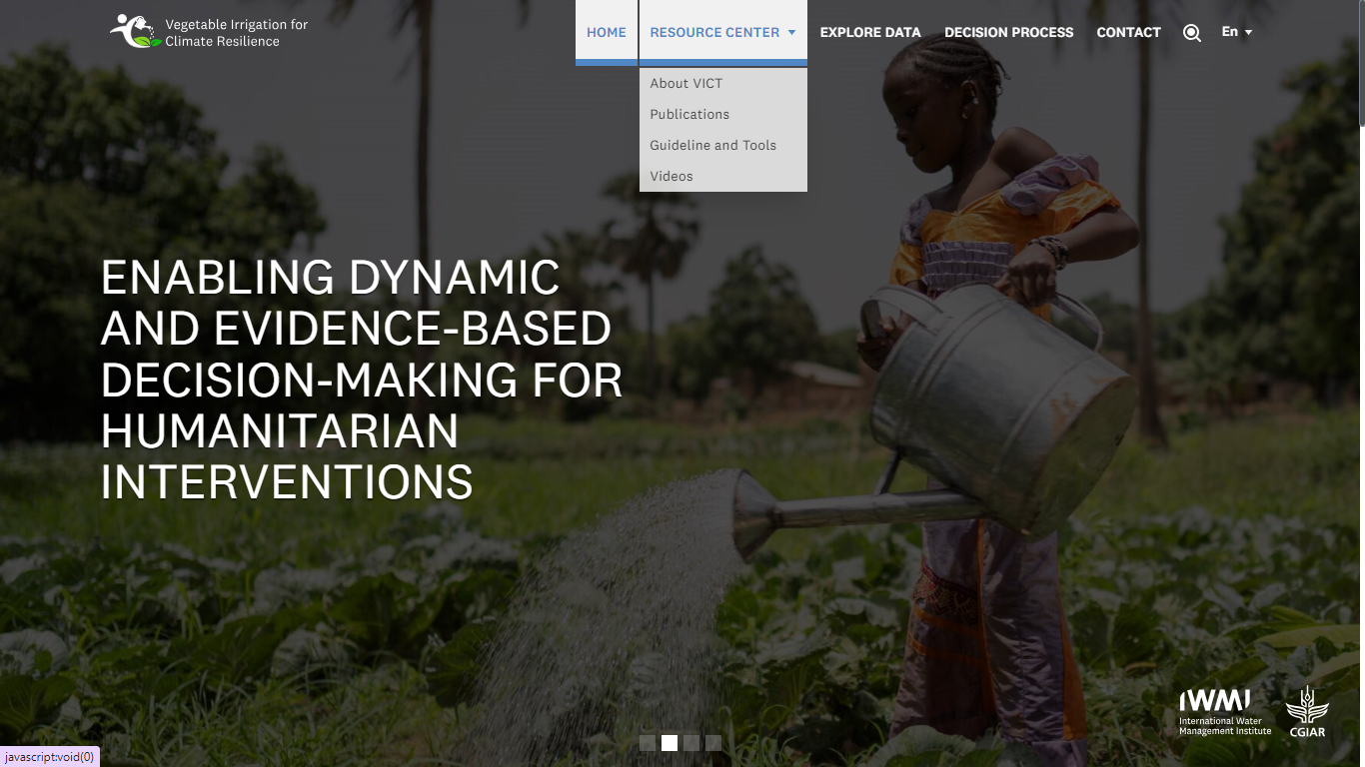Videos

### **2.2.1 ABOUT VICT**

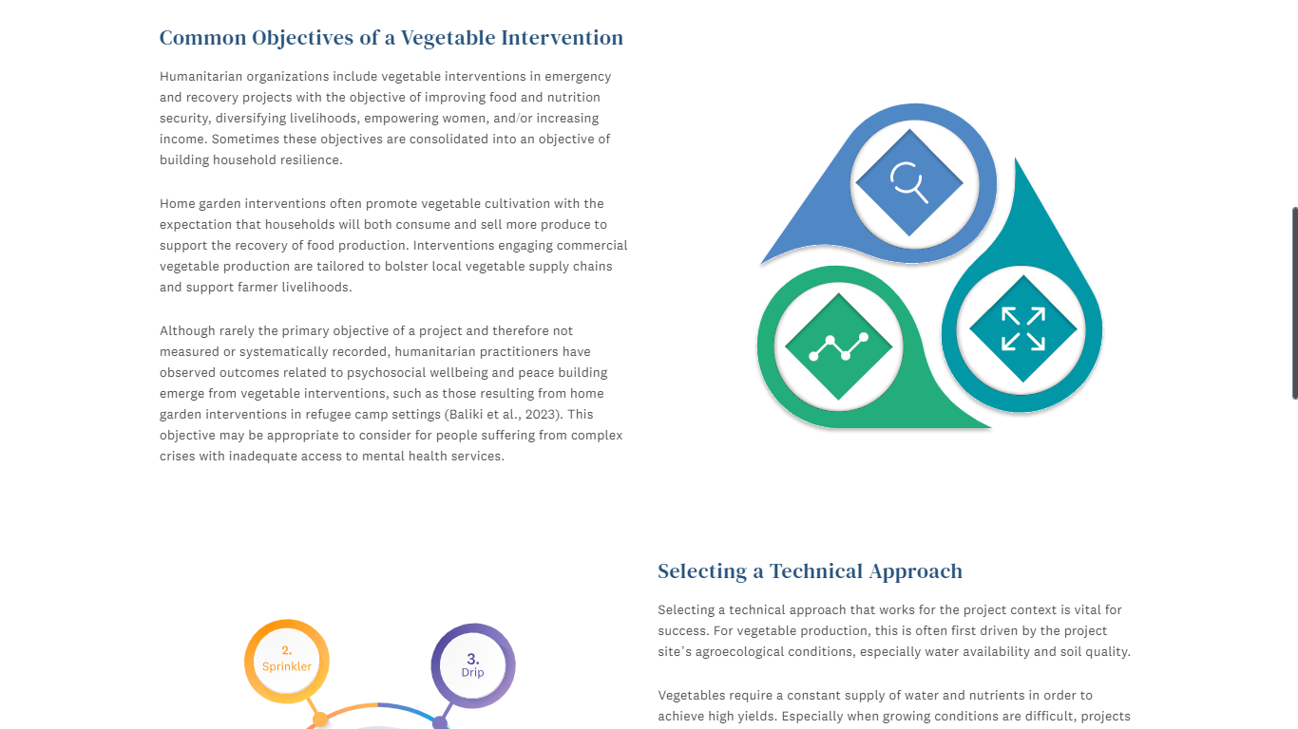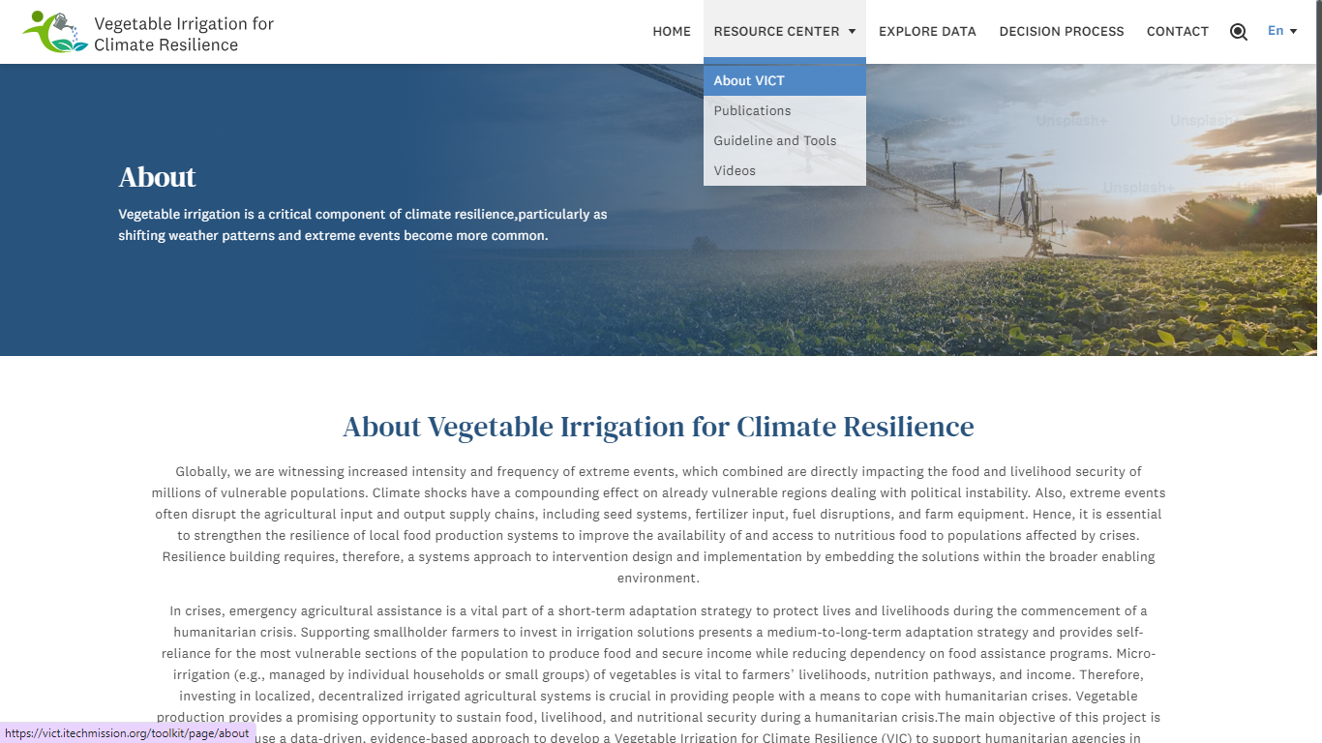The **About VICT** sub-module provides a brief overview of the VICT platform. It explains the platform's objectives, which focus on supporting climate-resilient irrigation practices for vegetable production. The module also outlines the technical approach used by VICT, highlighting the data-driven and evidence-based strategies that guide irrigation investments and climate adaptation efforts. This section gives users a clear understanding of the platform's purpose and the methods it employs to achieve its goals (see below figure).

### **2.2.2 PUBLICATION**

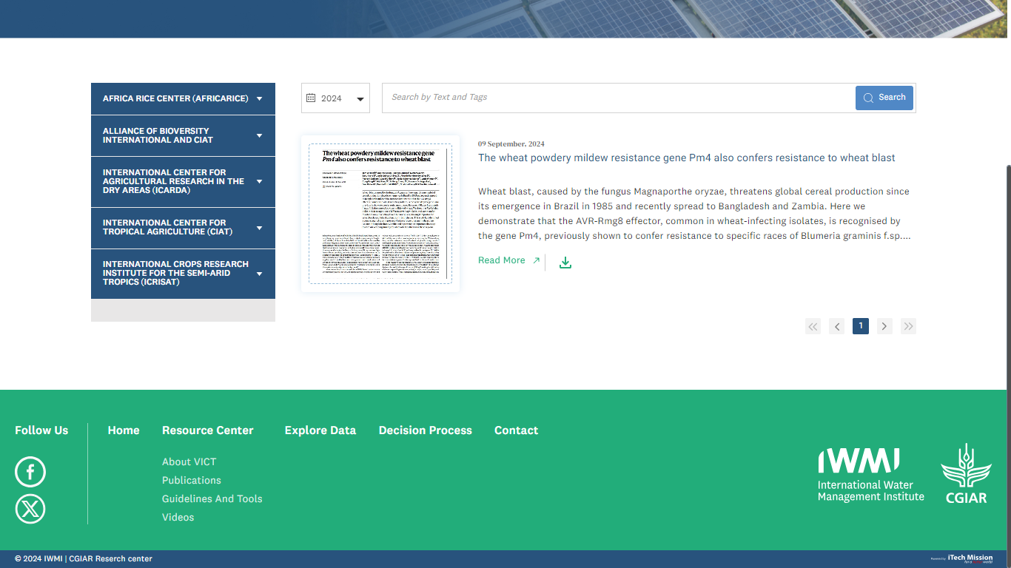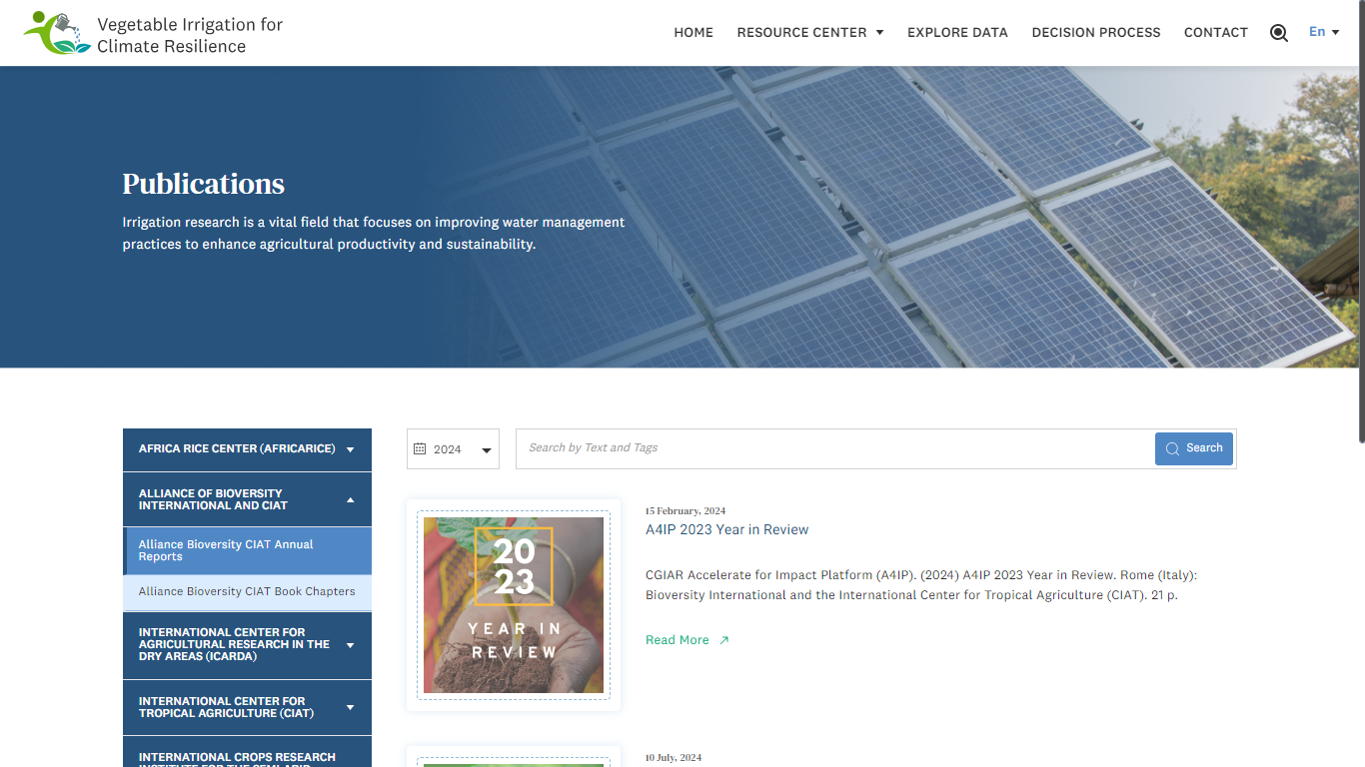The **Publications** sub-module presents resources related to the VICT platform by category. The categories are listed on the left side of the page, and the corresponding publications are displayed on the right. Each publication includes a brief description with options to Read More or Download any attached documents, if available. Users can also search for specific publications using a search bar or apply filters to view results by year (see below figure).

### **2.2.3 GUIDELINE AND TOOLS**

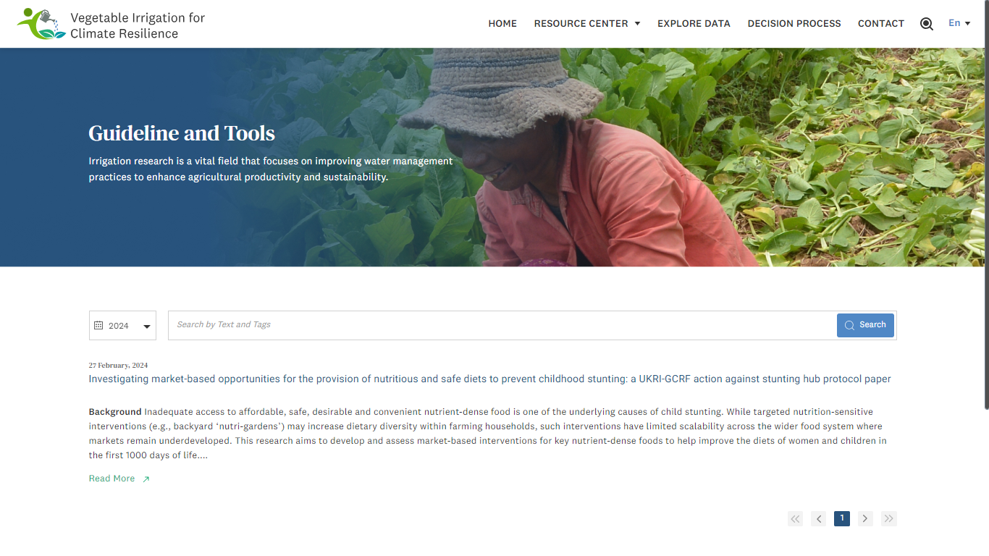The **Guideline and Tools** sub-module provides a collection of resources related to best practices, technical guidelines, and tools for vegetable irrigation and climate resilience. Each resource is presented with a header, date, brief description, and you have the option to **Read More**. Additionally, you can search for specific guidelines or tools and filter the results by year (see below figure).

### **2.2.4 VIDEOS**

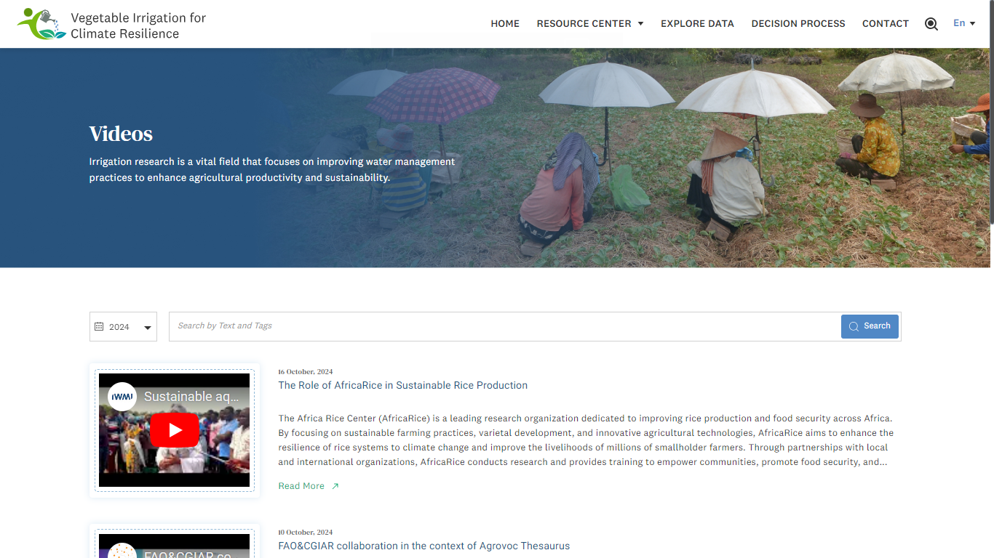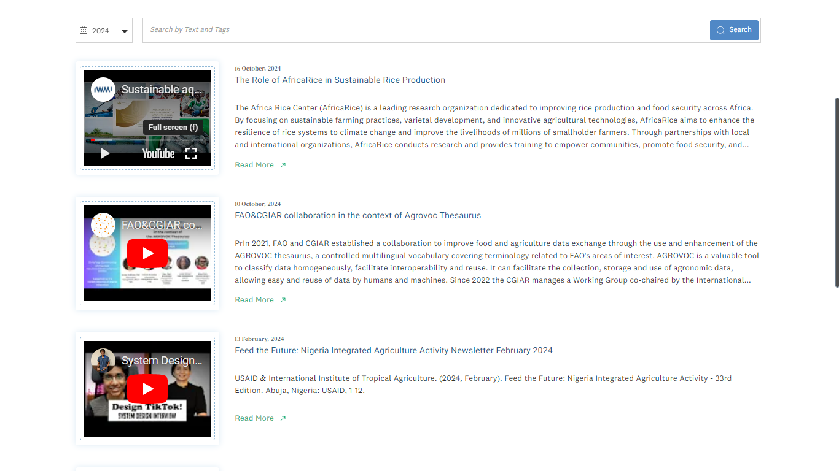The **Videos** sub-module provides a collection of video resources related to the VICT platform. Each video is presented with a header, date, and brief description, with the option to Watch the video in **Full Screen** and **Read More** for additional details. You can also search for specific videos and filter the results by year (see below figure).

## 2.5 CONTACT

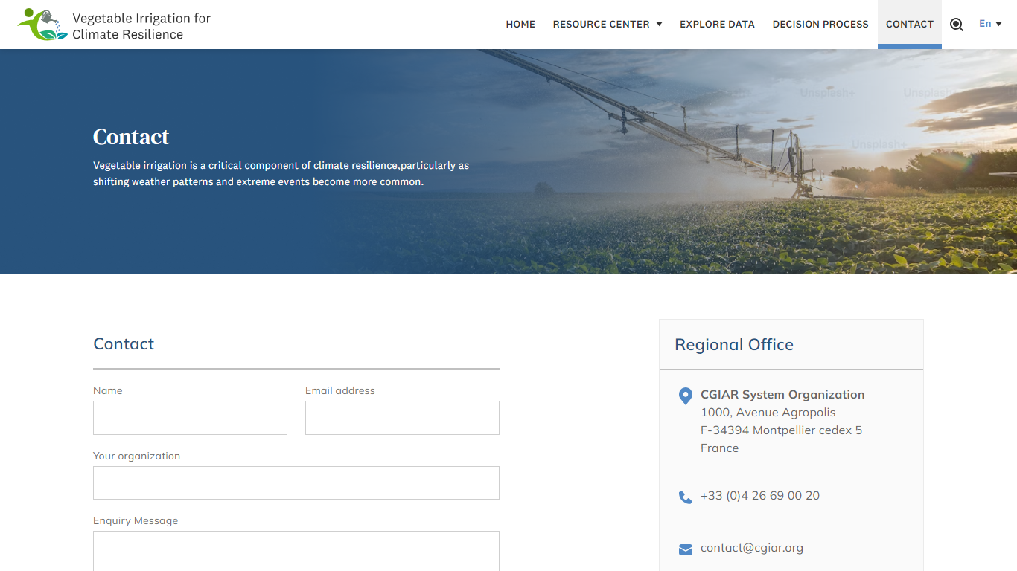Click on the **Contact** option from the home dropdown in the header to navigate to the module. This module provides contact details of the regional office of CGIAR System Organization, like phone numbers, email addresses, and office location. It also has a query form where you can ask questions. You have to add your Name, Email, your organization name and Enquiry Message, then click the send button to submit your query.

-----END OF THE DOCUMENT-----